|  |  |  |  |  |  |  |  |  |
| --- | --- | --- | --- | --- | --- | --- | --- | --- |
| **S****pecies** | ***t* 0** | ***L∞* (cm)** | ***K***  **(y-1)** | ***L*mat (cm)** | ***Tm* (y)** | **sex** | **area** | **source** |
| *Amblyraja radiata* |  | 66 | 0.233 | 46 | 4 | U | North Sea | [12] |
| *Eutrigla gurnardus* |  | 46 | 0.16 | 23 | 3 | U | North Sea | [5] |
| *Eutrigla gurnardus* |  |  | 0.21 | 18 | 1.5 | F | Irish Sea | [3] |
| *Eutrigla gurnardus* | 0.16 | 38 | 0.77 |  |  | F | Celtic Sea | [1] |
| *Eutrigla gurnardus* | 0.85 | 34.4 | 0.85 |  |  | M | Celtic Sea | [1] |
| *Eutrigla gurnardus* |  | 46.2 | 0.156 | 21 | 2.5 | U | North Sea | [12] |
| *Leucoraja circularis* |  | 98.8 | 0.121 | 51.2 | 5.3 | U | North Sea | [12] |
| *Leucoraja fullonica* |  | 98.8 | 0.121 | 51.2 | 5.3 | U | North Sea | [12] |
| *Molva dipterygia* | * | 155 | 0.13 | 85 |  | F | North Sea | [14] |
| *Molva dipterygia* | * | 113 | 0.157 |  |  | M | North Sea | [14] |
| *Molva dipterygia* |  |  |  | 50 | 6 | U | West Ireland/British Isles | [3] |
| *Molva dipterygia* |  | 155 | 0.126 | 77.8 | 5 | U | North Sea | [12] |
| *Molva molva* | * | 183 | 0.12 | 90 | 6.5 | F | North Sea | [14], [19] |
| *Molva molva* | * | 132 | 0.17 |  |  | M | North Sea | [14] |
| *Molva molva* |  |  |  | 67.5 | 9 | U | West Ireland/British Isles | [3] |
| *Molva molva* |  | 183 | 0.118 | 85 | 5.5 | U | North Sea | [12] |
| *Pollachius pollachius* |  | 85.6 | 0.19 |  |  | U | North Sea | [18] |
| *Pollachius pollachius* |  | 85.6 | 0.186 | 44.8 | 3.7 | U | North Sea | [12] |
| *Pollachius virens* |  | 107 | 0.19 | 55.4 | 4.6 | U | North Sea | [2], [18] |
| *Pollachius virens* |  | 177.1 | 0.07 | 55 | 4.6 | U | North Sea | [12] |
| *Pollachius virens* | -0.04 | 87.7 | 0.211 |  |  | M | North Sea | [4] |
| *Pollachius virens* | -0.58 | 120 | 0.15 |  |  | M | North Sea | [21] |
| *Psetta maxima* | -0.05 | 64.8 | 0.26 | 46 |  | F | North Sea | [15] |
| *Psetta maxima* | -0.51 | 49.2 | 0.37 |  |  | M | North Sea | [15] |
| *Psetta maxima* |  | 65.2 | 0.324 | 49 |  | M | Bay of Biscay | [9], [7] |
| *Psetta maxima* |  | 73.6 | 0.277 | 49 |  | F | Bay of Biscay | [9], [7] |
| *Psetta maxima* | -1.79 | 69.6 | 0.2497 | 49 | 4.5 | U | North Sea | [19], [8], [16], [17] |
| *Psetta maxima* |  | 57 | 0.32 | 46 | 4.5 | U | North Sea | [12] |
| *Psetta maxima* |  | 52.5 | 0.32 |  |  | M | North Sea | [17] |
| *Psetta maxima* | -1.79 | 70 | 0.148 |  |  | F | North Sea | [17] |
| *Raja batis* | -1.63 | 254 | 0.06 | 130 | 11 | U | North Sea | [11] |
| *Raja batis* |  | 253.7 | 0.057 | 155 | 15 | U | North Sea | [12] |
| *Raja brachyura* |  | 139 | 0.12 | 100 | 9.3 | U | North Sea | [12] |
| *Raja brachyura* | -0.8 | 118 | 0.19 |  |  | M | Irish Sea | [13] |
| *Raja brachyura* | -1.52 | 139 | 0.12 |  |  | F | Irish Sea | [13] |
| *Raja clavata* | -1.32 | 128 | 0.09 |  |  | F | Irish Sea | [13] |
| *Raja clavata* | -0.6 | 85.6 | 0.21 |  |  | M | Irish Sea | [13] |
| *Raja clavata* |  | 105 | 0.22 | 65 | 5 | U | North Sea | [12] |
| *Raja montagui* | -0.37 | 72.8 | 0.18 |  |  | F | Irish Sea | [13] |
| *Raja montagui* | -0.56 | 68.7 | 0.19 |  |  | M | Irish Sea | [13] |
| *Raja montagui* |  | 97.8 | 0.148 | 67 | 6 | U | North Sea | [12] |
| *Raja naevus* | -0.465 | 92 | 0.11 | 59 | 9 | U | North Sea | [11] |
| *Raja naevus* |  | 91.6 | 0.109 | 59 | 9 | U | North Sea | [12] |
| *Raja radiata* |  | 66 | 0.23 | 46 | 4 | U | North Sea | [22] |
| *Raja undulata* |  | 112 | 0.1 | 57.5 | 6.3 | U | North Sea | [12] |
| *Scophthalmus rhombus* |  | 74.88 | 0.14 | 37 |  | M | Bay of Biscay | [9], [7] |
| *Scophthalmus rhombus* |  | 85.23 | 0.147 | 37 |  | F | Bay of Biscay | [9], [7] |
| *Scophthalmus rhombus* |  | 50 | 0.27 | 37 | 4.5 | U | North Sea | [12] |
| *Sprattus sprattus* | * | 16 | 0.65 | 13 |  | U | North Sea | [20] |
| *Zeus faber* |  | 58 | 0.21 | 37 |  | U | Bay of Biscay | [20], [9], [10] |
| *Zeus faber* | * | 56.7 | 0.267 |  |  | U | Bay of Biscay | [6] |
| *Zeus faber* | * | 69.3 | 0.147 |  |  | F | Bay of Biscay | [6] |

**Table 1** life history parameters for MYDAS study species in North Atlantic. *L∞* is aymptopic maximum length. *K* is growth rate, *Tm*age at maturity and *Lmat* is length at maturity and *t0* time at which fish is at 0 length. * denotes missing from paper.

|  |  |  |  |  |  |  |  |  |
| --- | --- | --- | --- | --- | --- | --- | --- | --- |
| **species** | **trophic level** | **fecundity min** | **fecundity max** | **region** | **source** | **reproductive strategy** | **iucn** | **iucn colour** |
| *Eutrigla gurnardus* | 3.9 | 200000 | 300000 | North Sea | Fishbase | Broadcast spawner | Not evaulated | white |
| *Pollachius pollachius* | 4.3 |  |  |  | Fishbase | Broadcast spawner | Not evaulated | white |
| *Pollachius virens* | 4.3 | 677000 | 8985000 | North Sea | Fishbase | Broadcast spawner | Least concern | green |
| *Pollachius virens* | 4.3 | 220000 | 8260000 | Western North Atlantic | Fishbase | Broadcast spawner | Least concern | green |
| *Zeus faber* | 4.5 |  |  |  | Fishbase | Broadcast spawner | Data deficient | yellow |
| *Psetta maxima* | 4.4 | 5000000 | 1500000 | Unspecified | Fishbase | Broadcast spawner | Not evaluated | white |
| *Sprattus sprattus* | 3 | 8848 |  | North Sea | Fishbase | Broadcast spawner | Not evaluated | white |
| *Scophthalmus rhombus* | 4.4 |  |  |  | Fishbase | Broadcast spawner | Not evaluated | white |
| *Molva dypterygia* | 4.5 |  |  |  | Fishbase | Broadcast spawner | Not evaluated | white |
| *Molva molva* | 4.4 | 600000 |  |  | Fishbase | Broadcast spawner | Not evaluated | white |
| *Raja clavata* | 3.8 | 0 | 142 | British waters | Fishbase | Demersal egg layer | Near threatened | red |
| *Amblyraja radiata* | 4.2 | 56 |  | CanadianWaters | Fishbase | Demersal egg layer | Vunerable | red |
| *Raja brachyura* | 3.8 | 30 |  | Eastern Atlantic | Fishbase | Demersal egg layer | Near threatened | red |
| *Leucoraja naevus* | 4.2 | 90 |  | Atlantic | Fishbase | Demersal egg layer | Least concern | green |
| *Raja montagui* | 3.9 | 24 | 60 | Unspecified | Fishbase | Demersal egg layer | Least concern | green |
| *Raja batis* | 3.5 | 40 |  | North Sea | Fishbase | Demersal egg layer | Critically endangered | red |
| *Raja undulata* | 3.5 |  |  |  | Fishbase | Demersal egg layer | Endangered | red |

**Table 2** reproductive strategy, status and trophic level

**Table 3** post capture survival.

|  |  |  |  |  |  |
| --- | --- | --- | --- | --- | --- |
| **species** | **gear** | **survival lower** | **survival upper** | **source** | **area** |
| *Eutrigla gurnardus* | Beam trawl | 0 | 0 | Fulton (1890) | UK |
| *Bathyraja spp.* | Longline | 96 | 100 | Benoit and Hurlbut (2010) | Canada |
| *Rajidae* | Otter trawl | 55 | 55 | Enever (2009) | UK |
| *Rajidae* | Otter trawl | 55 | 67 | Enever (2010) | UK |
| *Pollachius virens* | Shrimp trawl | 48 | 89 | Ross and Hokenson (1997) | USA |
| *Pleuronectes platessa* | Beam trawl | 0 | 48 | van Beek et al. (1990) | UK |
| *Pleuronectes platessa* | Shrimp trawl | 12 | 70 | Kelle (1976) | UK |

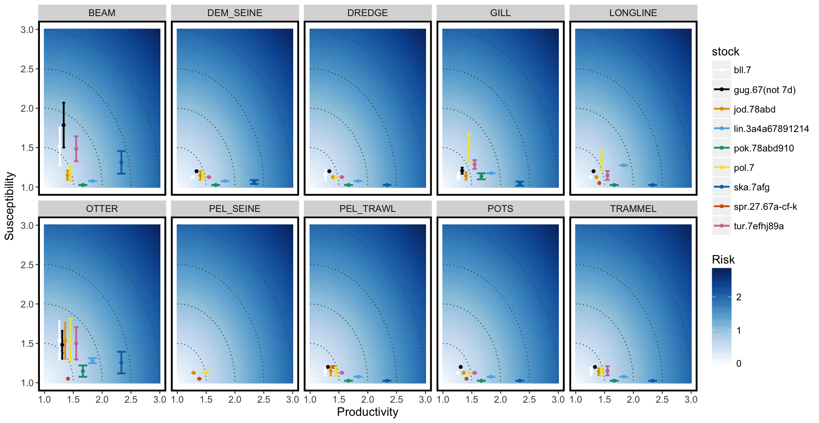

**Figure 1** PSA analysis.

**References**

1. Baron, J. (1985. Les Triglides (Téléostéens, Scorpaeniformes) de la Baie de Douarnenez. I La croissance de : Eutrigla gurnardus, Trigla lucerna, Trigloprus lastoviza et Aspitrigla cuculus. Cybium 9(2) : 127-144.
2. Beverton, R.J.H. & Holt, S.J.  (1959).  A review of the lifespan and mortality rates of fish in nature and their relationship to growth and other physiological characteristics.  Ciba Foundation Colloquium on Ageing, 68, 142 180.
3. Clarke, M.W. (2005). A Life History Approach to the Assessment of Deep_Water Fisheries in the Northeast Atlantic, Deep Sea 2003: Conference on the Governance and Management of Deep_Sea Fisheries. Shotton, R., Ed., FAO Fish. Proc., 2005, nos. 3/1, pp. 196–210.
4. Damas, D. 1909. Contribution à la biologie des gadids. Rapp. P-v. Réu. Con. Inter. pour l’Explor. Mer 10: 1–277.
5. Damm, U.  (1987). Growth of the grey gurnard *Eutrigla gurnadus L.* in the North Sea. *International Council for the Exploration of the Seas, Committee Meeting,* G: 55. mimeo.
6. Desbrosses, P. (1937). Note sur le Saint Pierre de Mauritanie, du Senegal et de Guinée, Zeus faber L. mauritaicus nation nova. Rev. Trav. Off. Pêch. Marit. 10 (3):379-414.
7. Deniel, C. (1981). Les poissons plats (TelCostCens, Pleuronecti- formes) en baie de Douarnenez. Reproduction croissance et migration des Bothidae, Scophthalmidae, Pleuronectidae et Soleidae. These, Universite Bretagne Occidentale, Brest. 476 PP.
8. Deniel, C. (1990). Comparative study of growth of flatfishes on the west

coast of Brittany. *Journal of Fish Biology*, 37: 149–166.

1. Dorel, D. (1986). Poissons de l’Atlantique Nord-Est Relations tailles-poids.
2. Dorel, D., Cadiou, Y., Porcher, P. (1998). Poissons, crustacés et mollusques des mers 476 communautaires. Paramètres biologiques et représentations graphiques. IFREMER.
3. Du Buit, M. H. (1977). Age et croissance de *R. batis* et de *R. naevus* en Mer Celtique. Journal du Conseil International pour l’Exploration de la Mer 37:261–265.
4. Greenstreet, S.P.R., Rossberg, A.G., Fox, C.J., Le Quesne, W.J.F., Blasdale, T., Boulcott, P., Mitchell, I., Millar, C., Moffat, C.F. (2012). Demersal fish biodiversity: species- level indicators and trends-based targets for the Marine Strategy Framework Directive. *ICES J. Mar. Sci*. 69, 1789–1801.
5. Holden, M. J. (1972). The growth rates of R. brachyura, R. clavata and R. montagui as determined by tagging data. *Journal du Conseil International pour l’Exploration de la Mer* 34:161–168.
6. Joenoes, G. (1961). Ber. Deut. Wiss. Komm.16, 129.
7. Jones, A. (1974). Sexual maturity, fecundity and growth of the turbot, *Scophthalmus maximus L*. Journal of the Marine Biological Association of the UK, 54: 109–125.
8. Knijn, R.J., Boon, T.W., Heessen, H.J.L., Hislop, J.F.G. (1993). “Atlas of North Sea Fishes” (ICES Coop. Res. Rep. 194, ICES, Copenhagen, 1993).
9. Mengi, T. (1963). Ber. Deut. Wiss. Komm. 7, 119.
10. Moreau, J. (1964). Contribution a` l’e´tude du lieu jaune (*Gadus pollachius*

*L.*). Revues de Traveaux Institut de Peˆches Maritimes, 28:237–255.

1. Muus, B.J., Nielson, J. G. (1999). Sea Fish (Scandinavian Fishing Year Book, Hedehusene, Denmark.
2. Pauly, D. (1978). A preliminary compilation of fish length growth parameters.

Berichte des Institut fu¨r Meereskunde an der Universita¨t Kiel, 55. 200 pp.

1. Schmidt, U. (1959). German investigations on commercial saithe landings in 1958/59. Bulletin Statistique Conseil International pour l’Exploration de la Mer 8, 37–42.
2. Vinther, M.  (1989).  Some notes on the biology of the starry ray, *Raja radiata*, in the North Sea. Working document: ICES Study Group on Elasmobranch Fisheries, 4/1989, 1–20. mimeo.